|  |  |
| --- | --- |
| Echolink installation and set-up guide | Abstract  This is a quick set-up guide for Windows-based computer users. It contains some customization tips and samples for firewall and port forwarding for certain EchoLink functionality.  By  Beth McEwen (KM4GRQ) |

Table of Contents

Basic Installation 2

Validation 11

Customization 17

Port Forwarding 25

Introduction to Port Forwarding 25

Port Forwarding Steps 26

# Basic Installation

1. Go to: <http://www.echolink.org/> the screen will look like this:

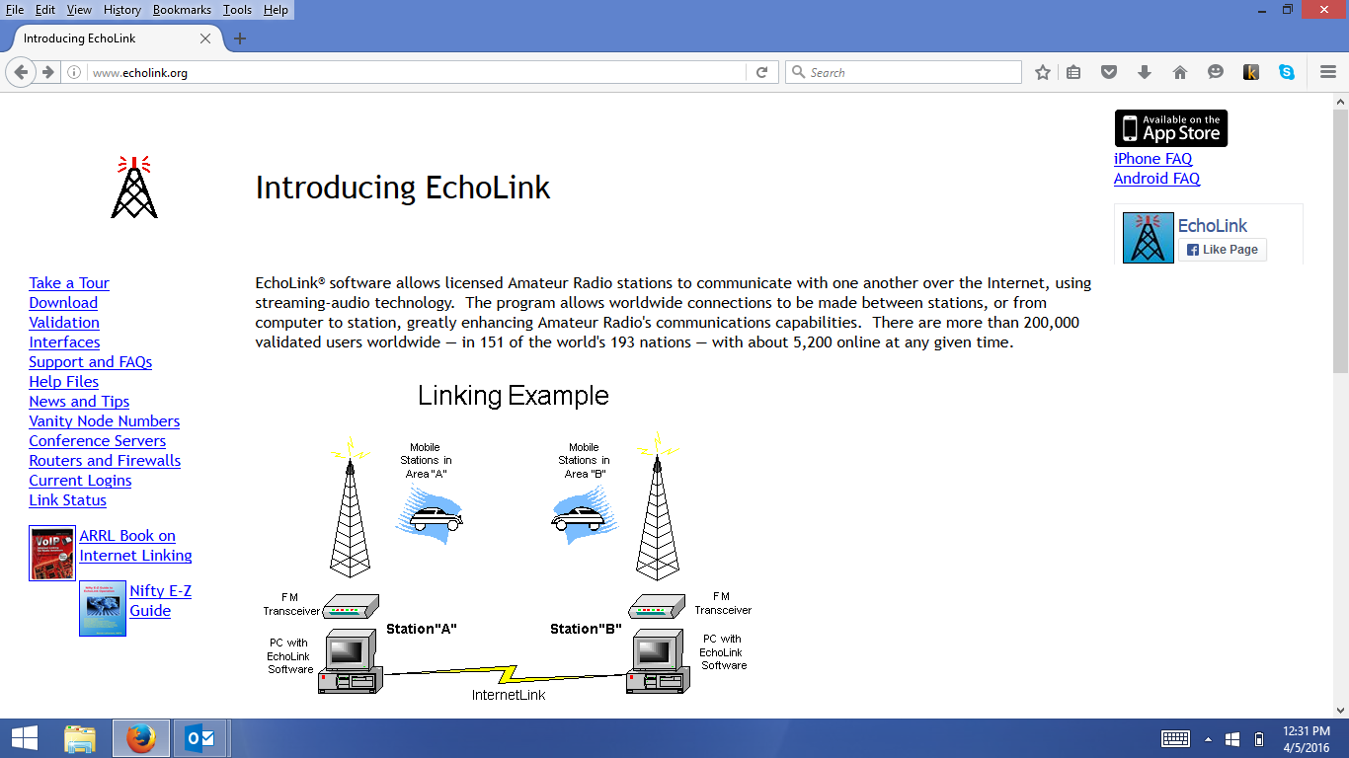

1. Click the Download link on the left side of the screen. The result looks like this:

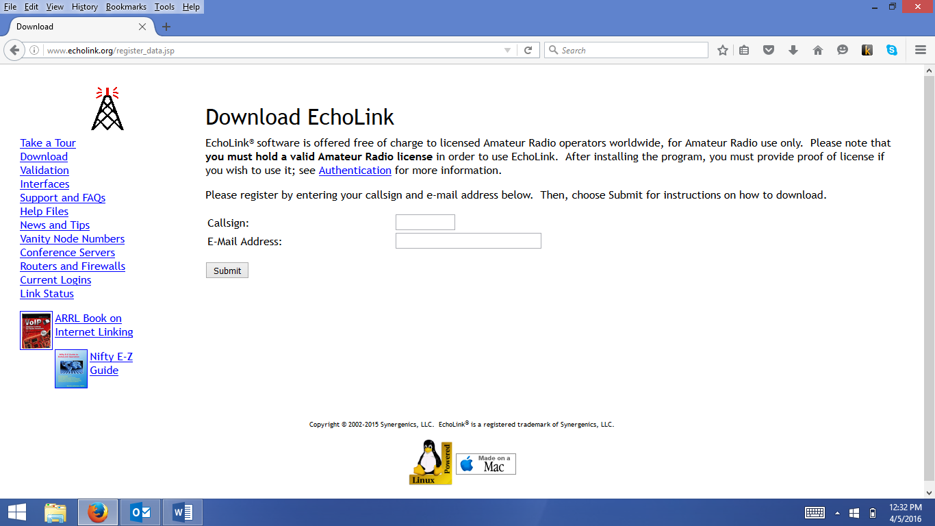

1. Enter your call sign and email address in the spaces provided and click “Submit”. The screen looks like this:

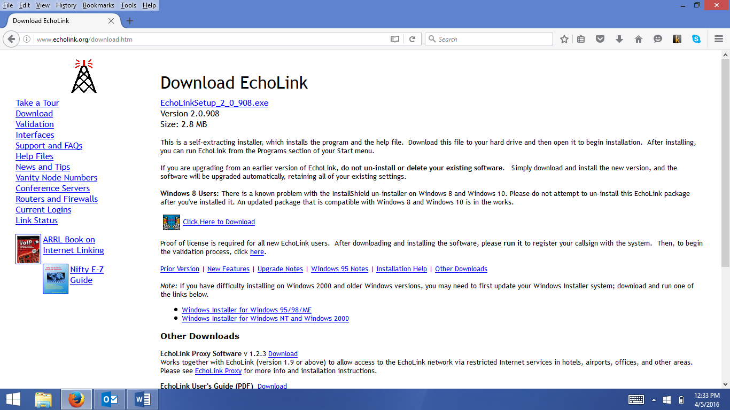

1. Click on the appropriate download for your system and follow the InstallShield prompts.
2. The EchoLink installation puts an icon on your desktop that looks like the one, below. Double-click it to begin, then click Next.

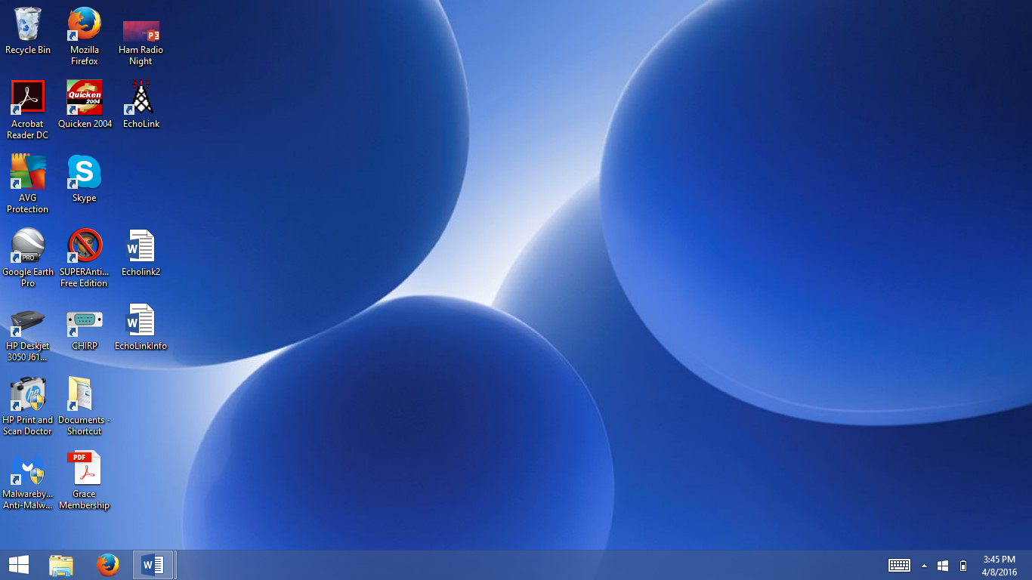

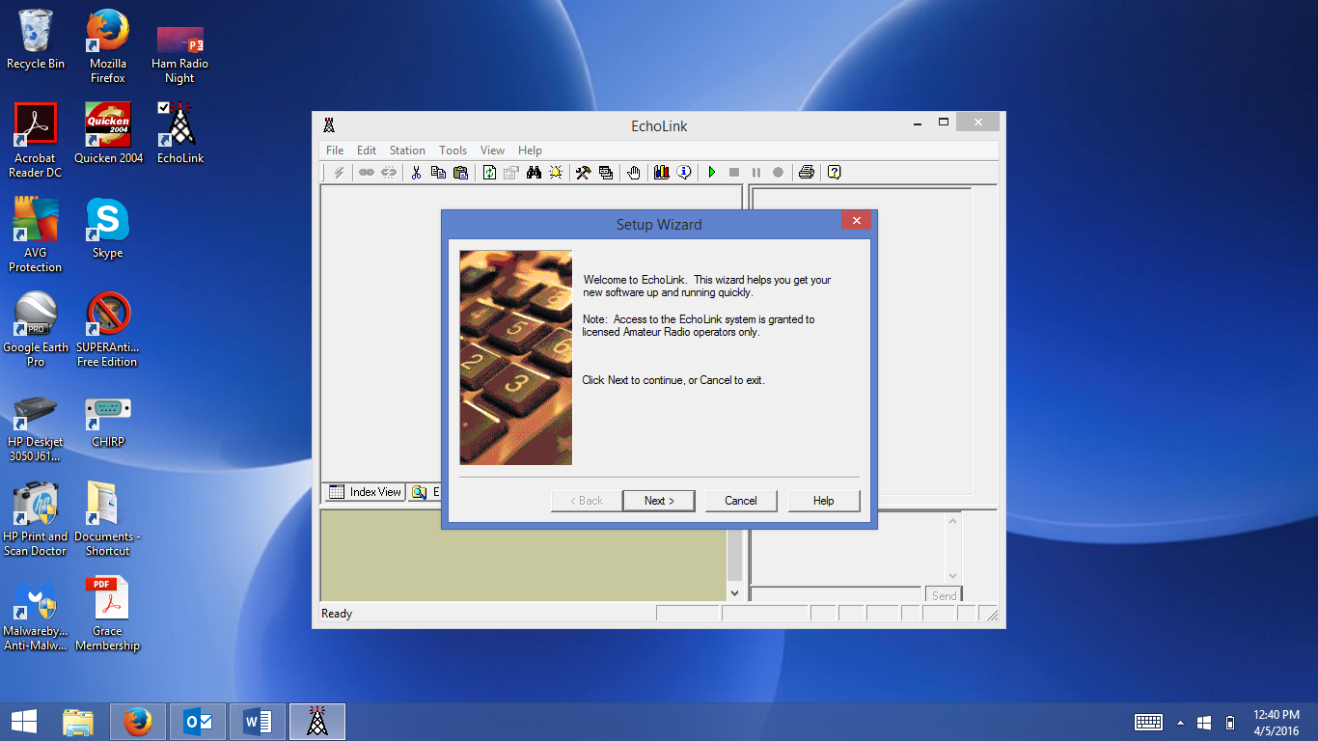

1. Make sure “Computer User” is selected and click on “Next”:

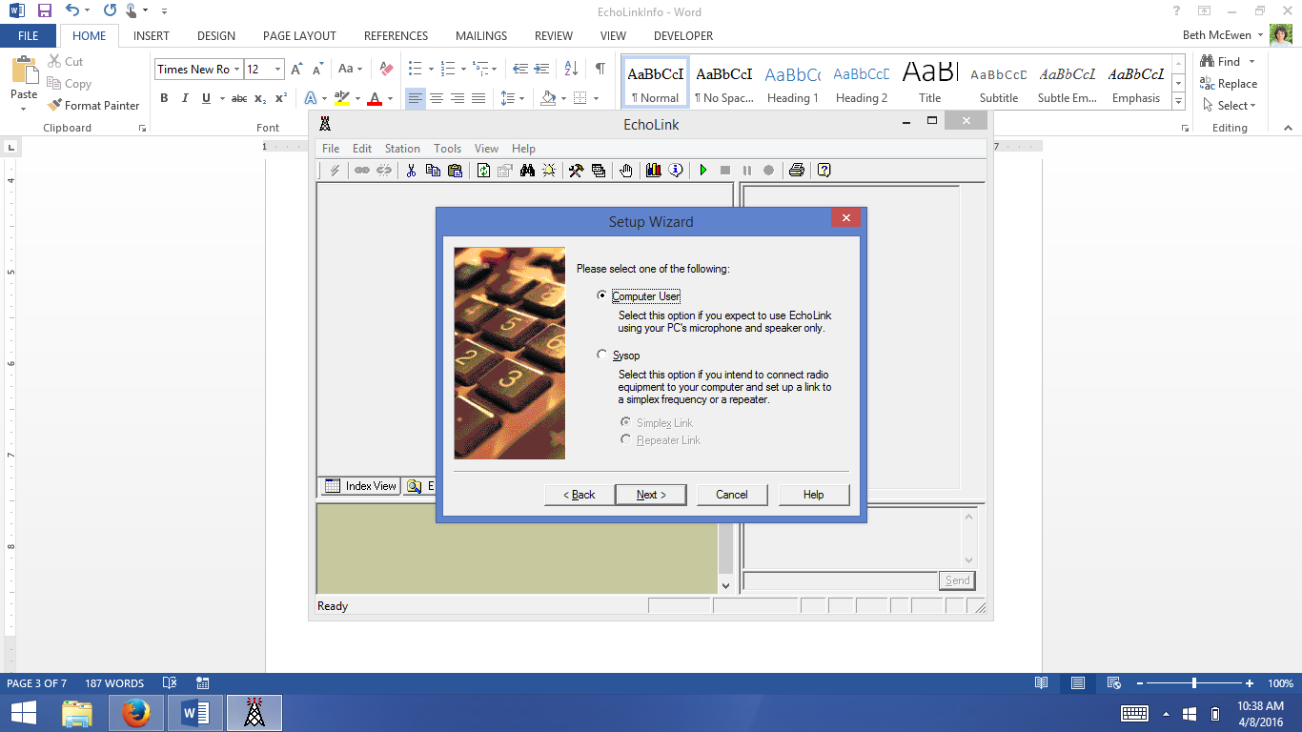

1. Select “DSL, cable, ISDN, or other (above 56K)”, then click “Next”.

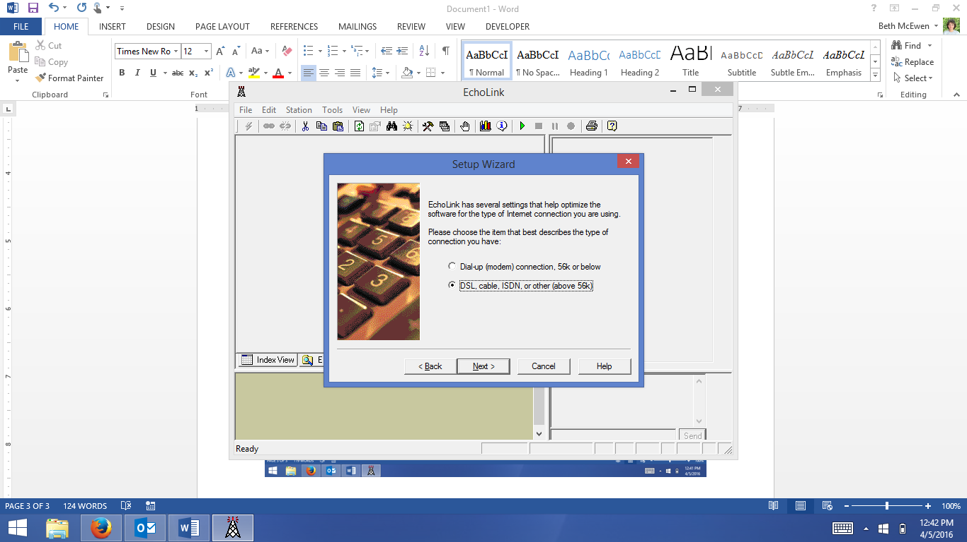

1. Fill in your call sign, password, your first name, location, and finally, your email address. Click “Next” (this is part of the validation process).

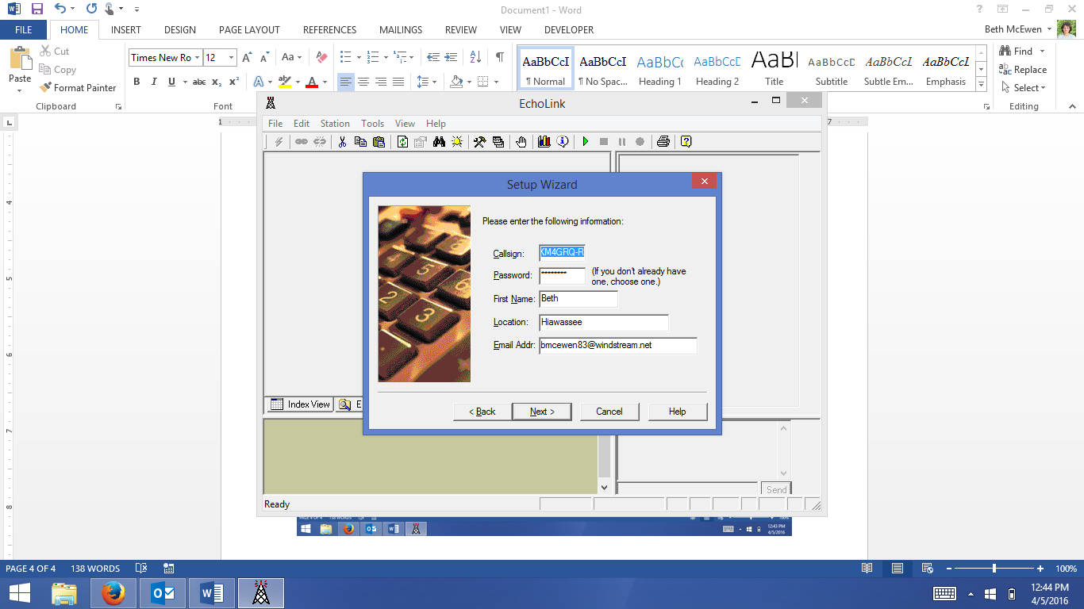

1. Be sure “North America – South” is checked, then click “Next”.

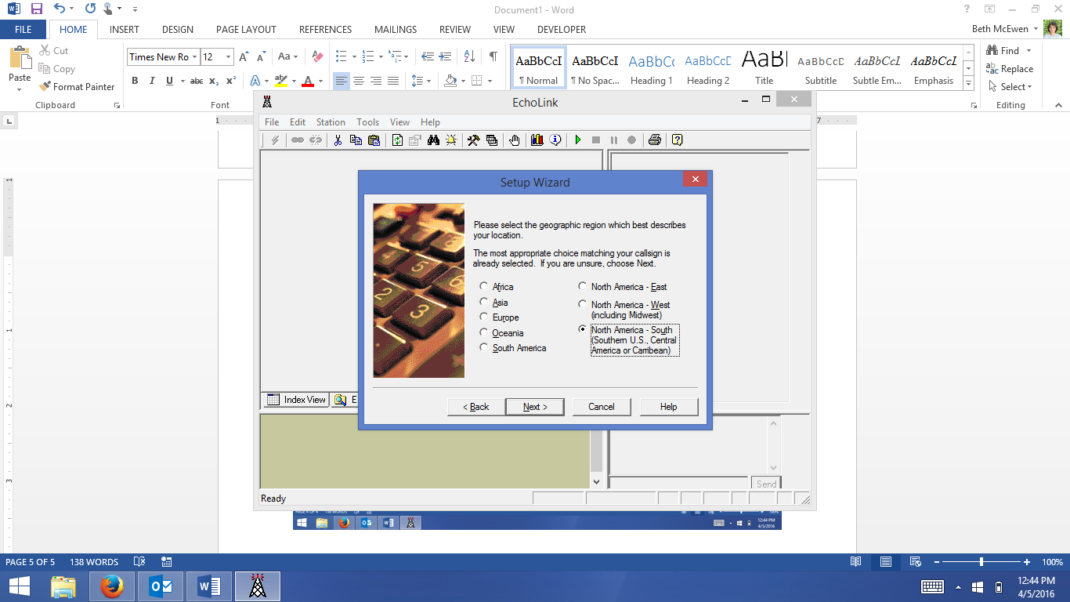

1. Now you can perform a Firewall test. This is strongly recommended. Click on the Firewall Test button.

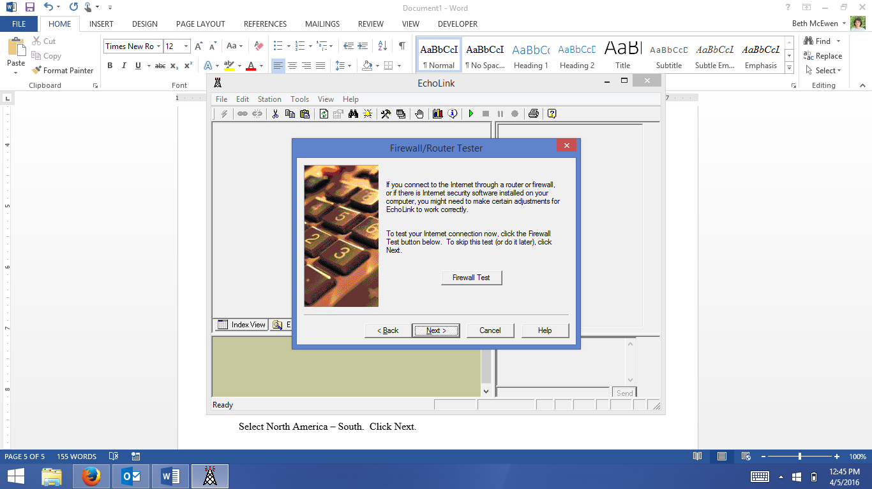

1. If you have not set ports 5198 and 5199 for TCP/UDP forwarding, then you will get a failure message similar to the one below:

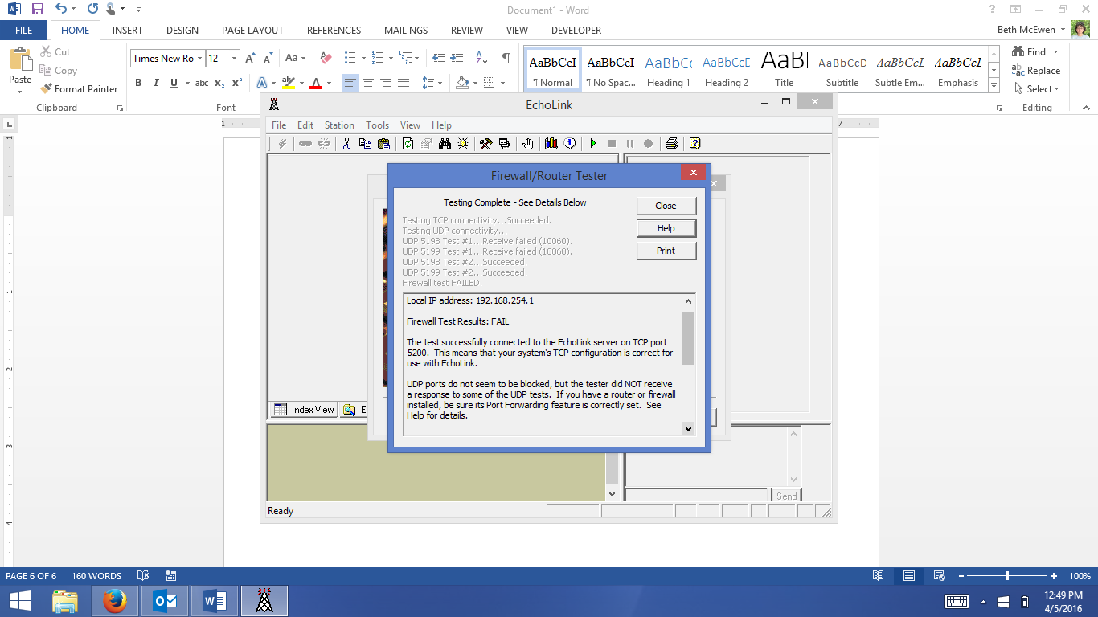

When port forwarding is correctly set, the screen will look like this:

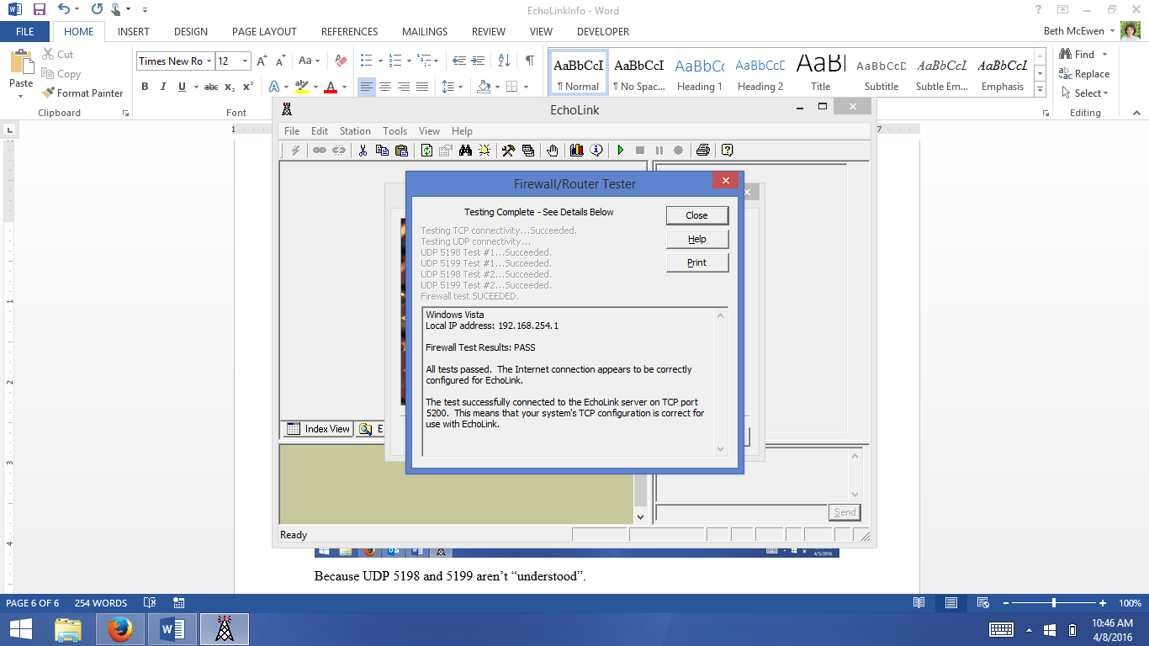

See the “Port Forwarding” section of this document for basic instructions on how to perform this step.

1. When the installation process is complete, you’ll get a screen like this:

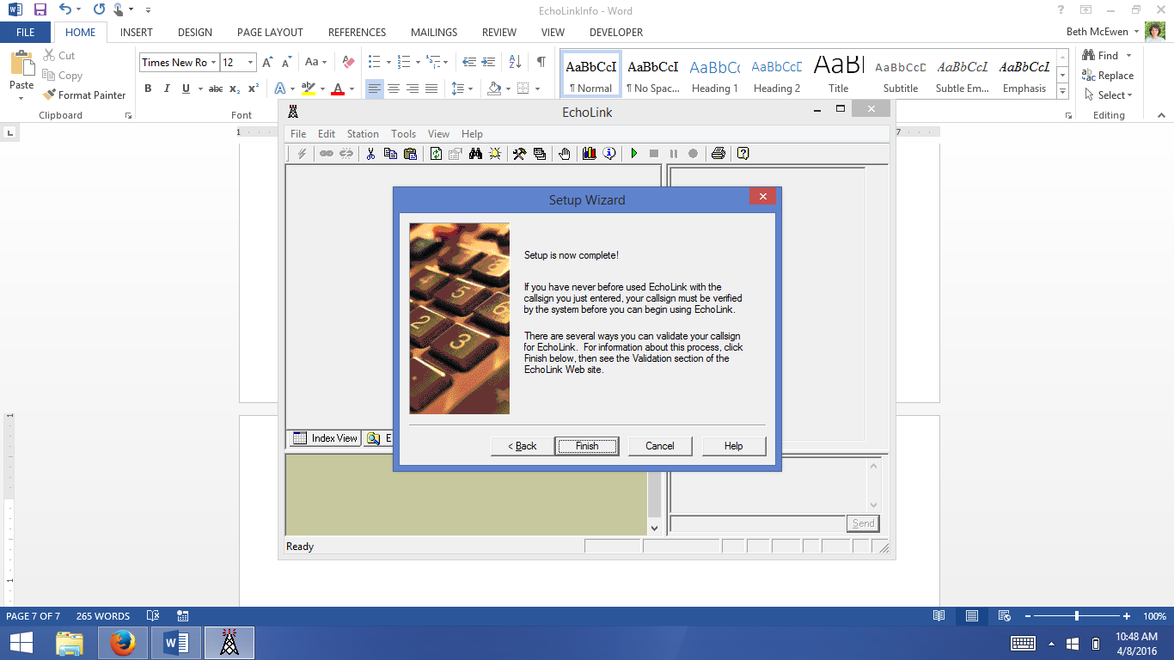

# Validation

1. If you try to validate your call sign before installing and running EchoLink, you’ll get a screen that looks like this:

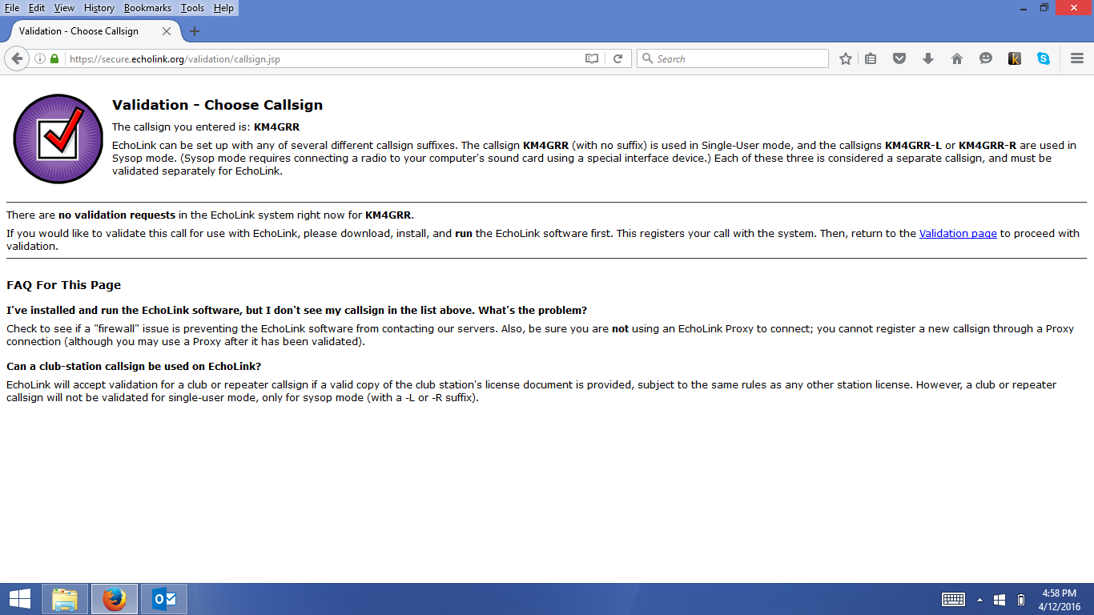

1. After you run the installation and set-up and attempt your first sign-in, you’ll get this message from the EchoLink application:

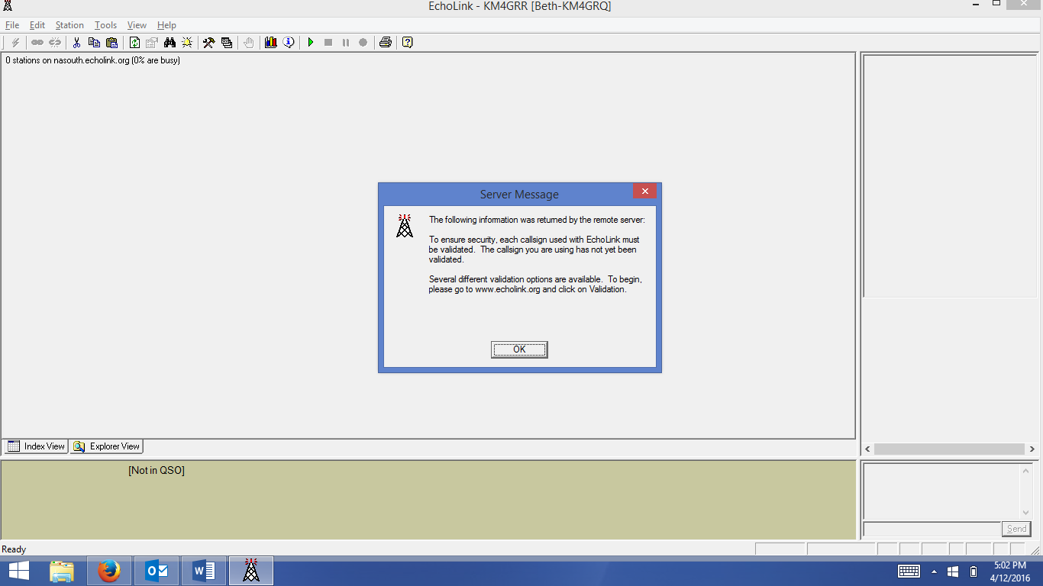

1. Go back to [www.echolink.org](http://www.echolink.org) and click on the “Validation” link on the left of the screen. The result will look like this:

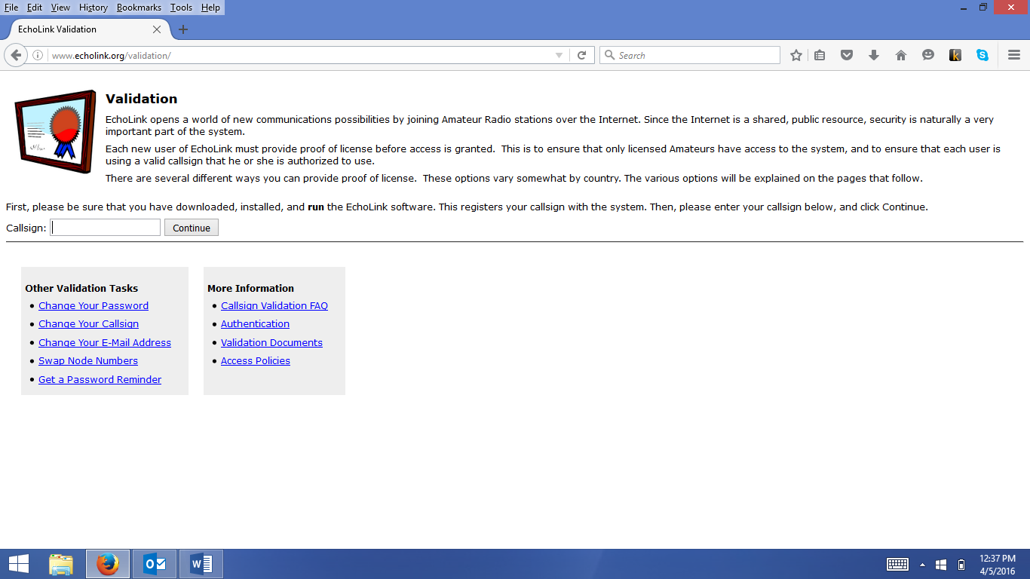

1. Enter your call sign and click “Continue”.

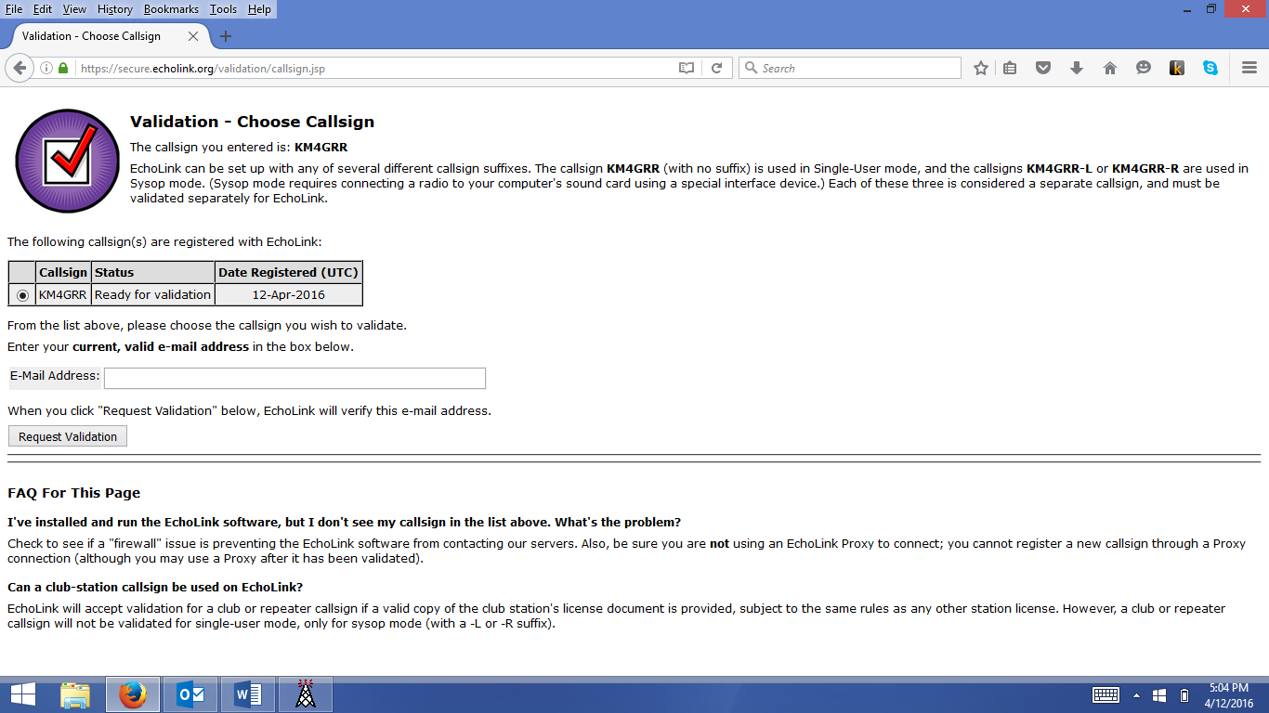

1. Enter your email address in the space provided and click “Request Validation”.
2. You’ll get this screen:

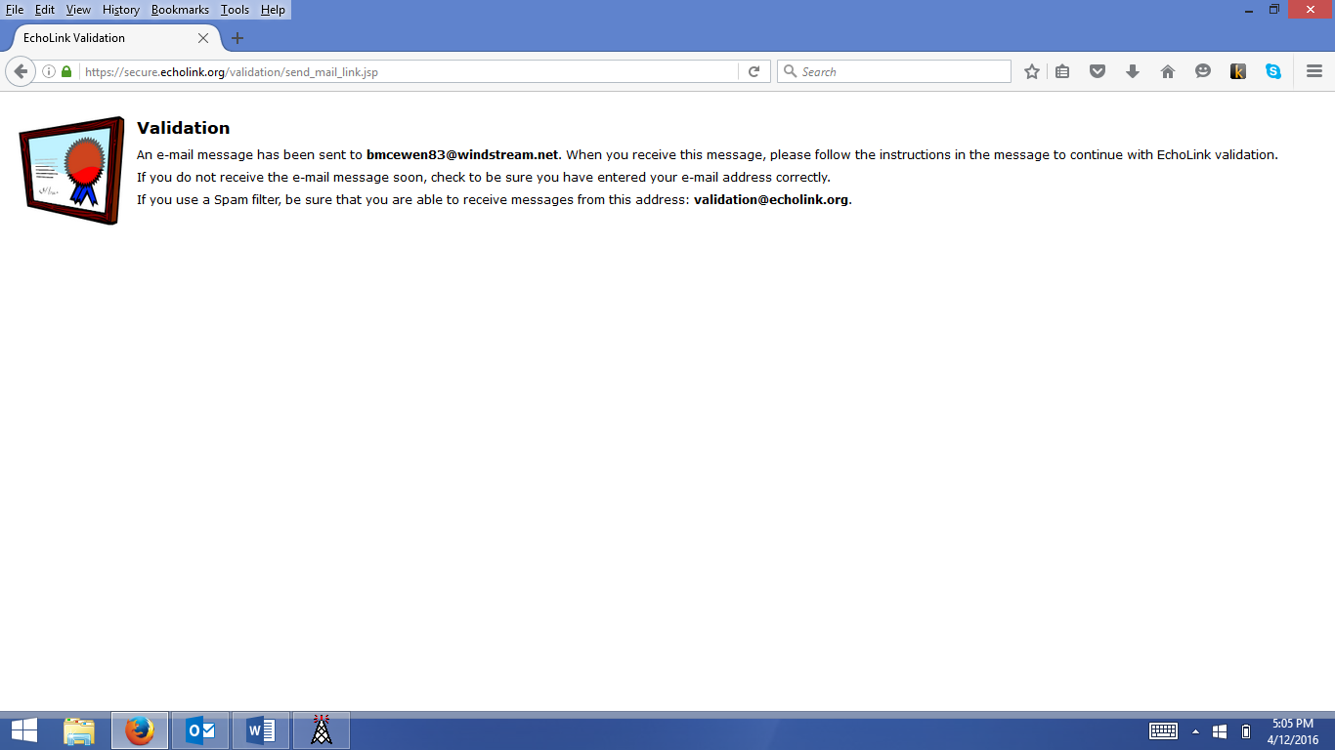

1. Check your email for one that looks like this one:

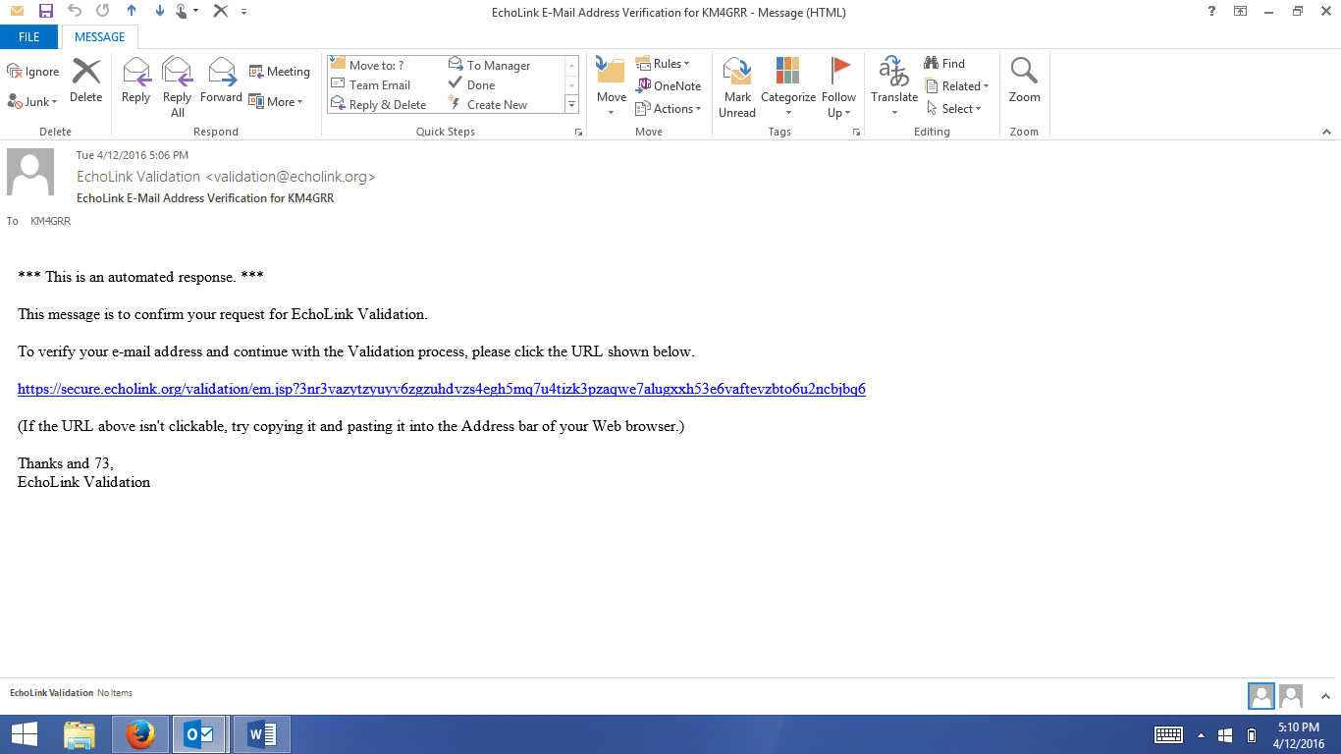

1. Click on the link provided (or copy/paste it into your browser). Here’s the screen you’ll get:

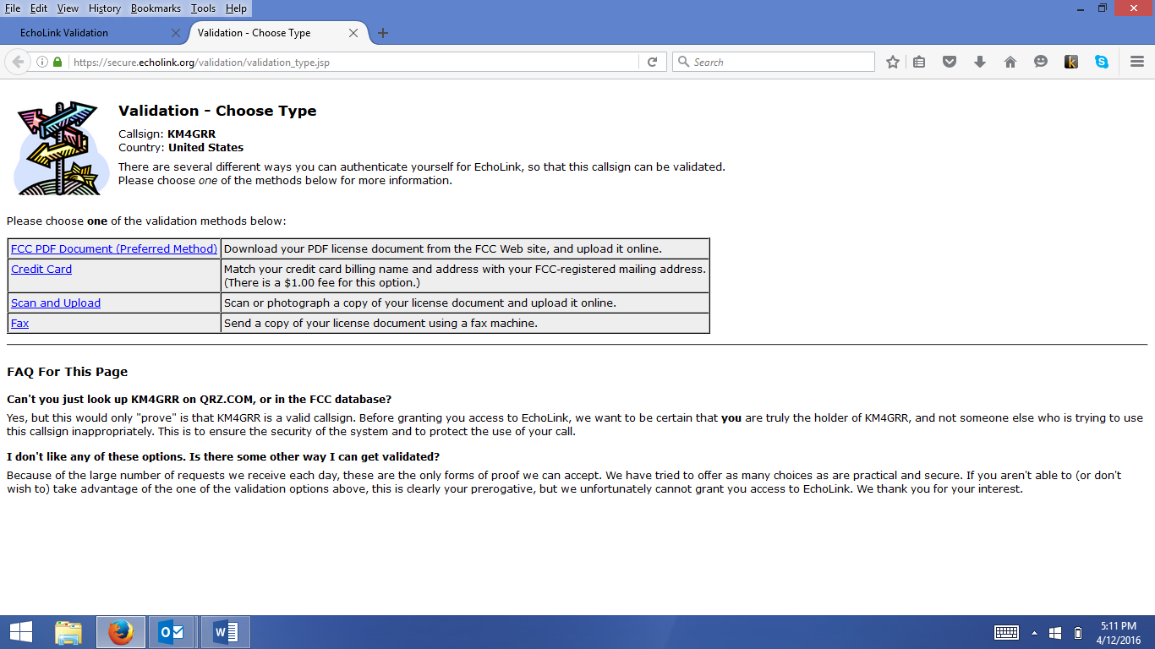

1. If you’ve downloaded a copy of your license from the FCC website (highly recommended), click on the first option, “FCC PDF Document (Preferred Method)”. You’ll see this screen:

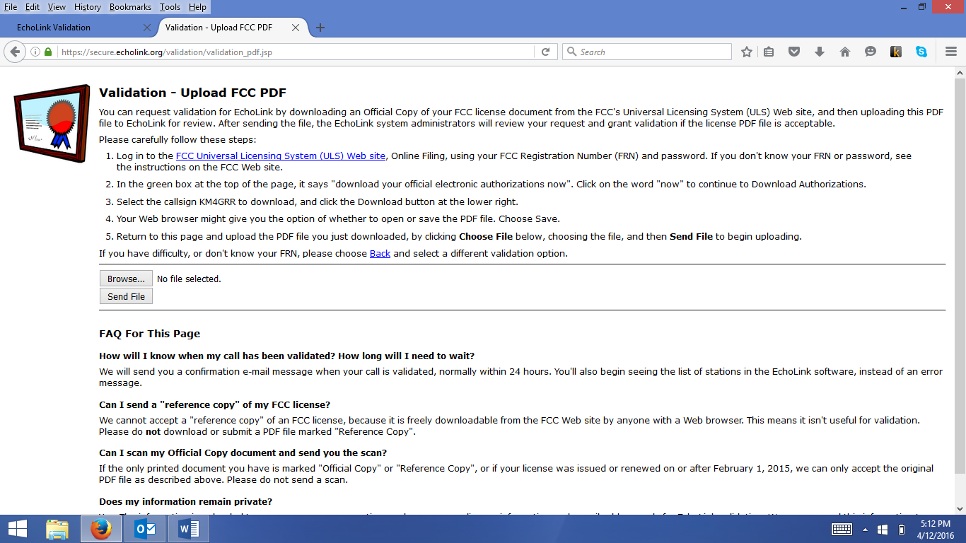

1. Click the “Browse” button to navigate to where you have your license stored on your computer. When you locate the file, double-click on the filename, and you are brought back to this screen:

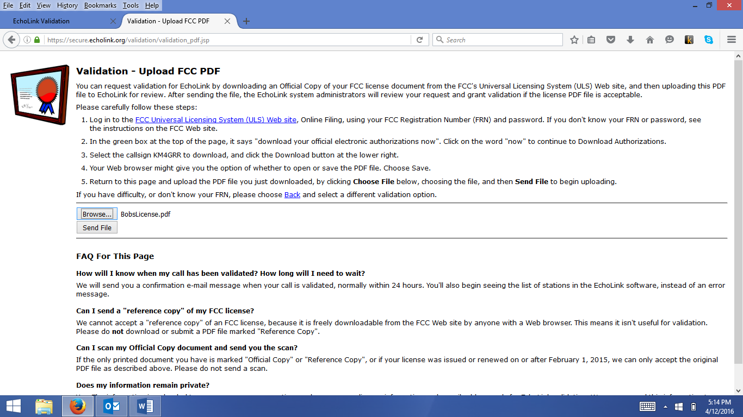

1. Now, click on “Send File”. You’ll get a screen similar to the following:

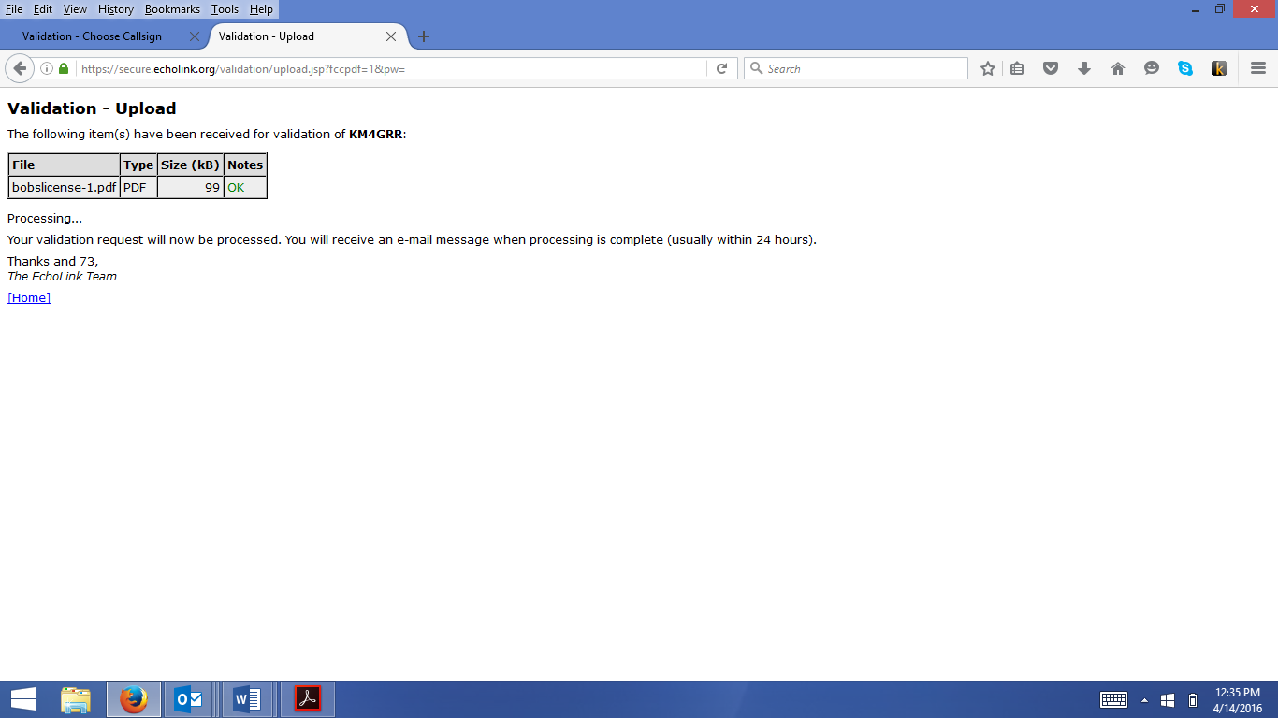

1. You’ll receive an email similar to the one below, confirming that your license has been validated and EchoLink will be ready to use.

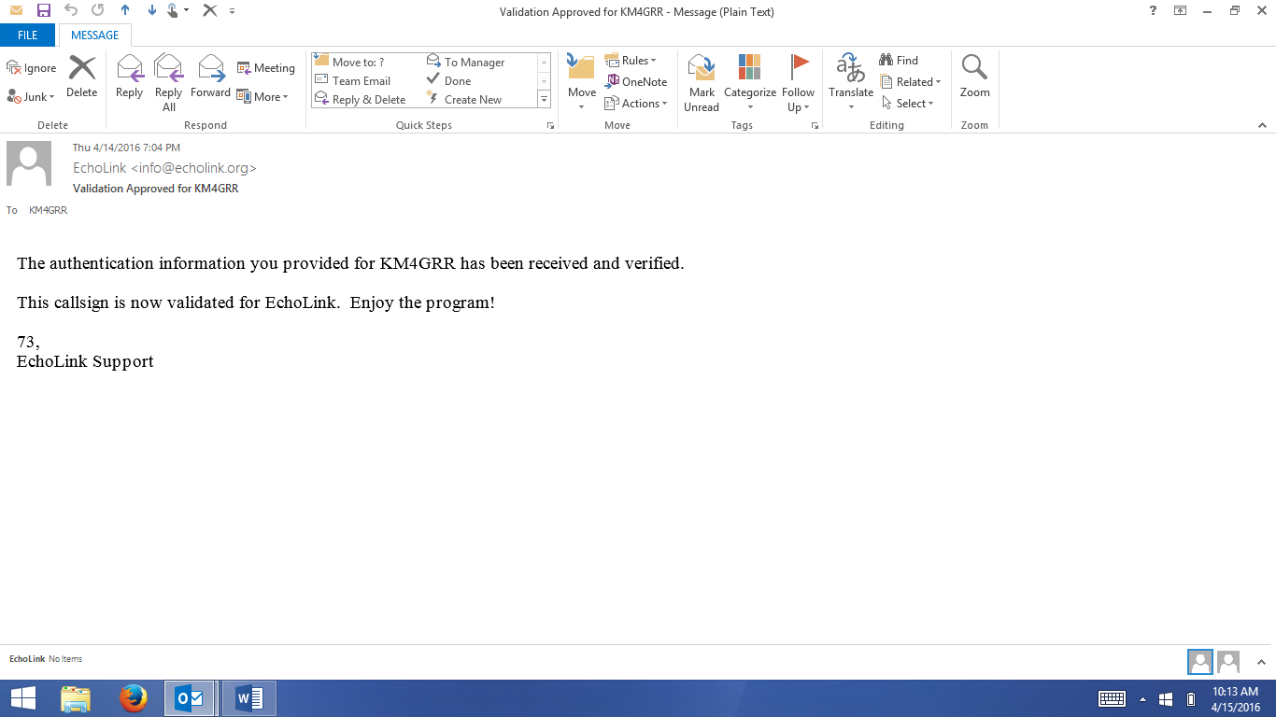

# Customization

1. When you start EchoLink, the default is to show the tip of the day:

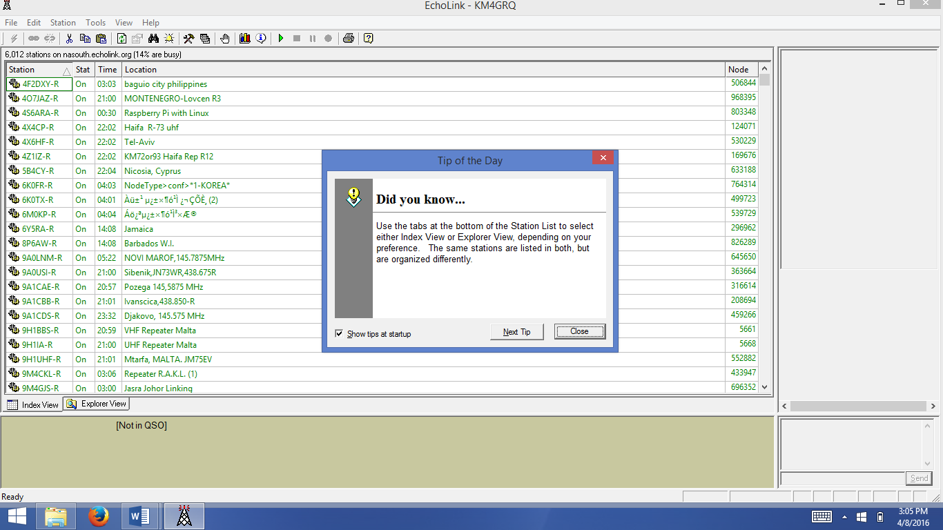

This can be annoying! To turn this off, click the box in the bottom left corner (the default is to have it checked).

1. Your initial EchoLink screen will look similar to the following:

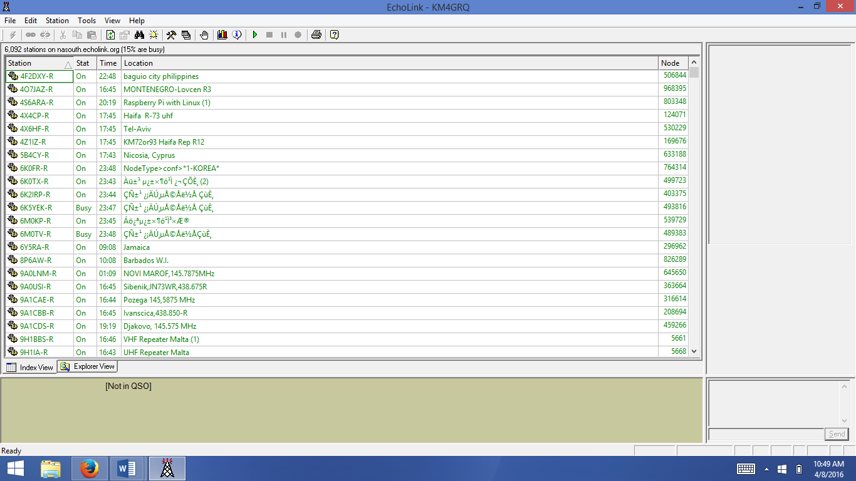



The above is called “Index View”. You can adjust what you want to see by accessing the preferences button circled in red, above.

Here’s a snapshot of the Preferences box:

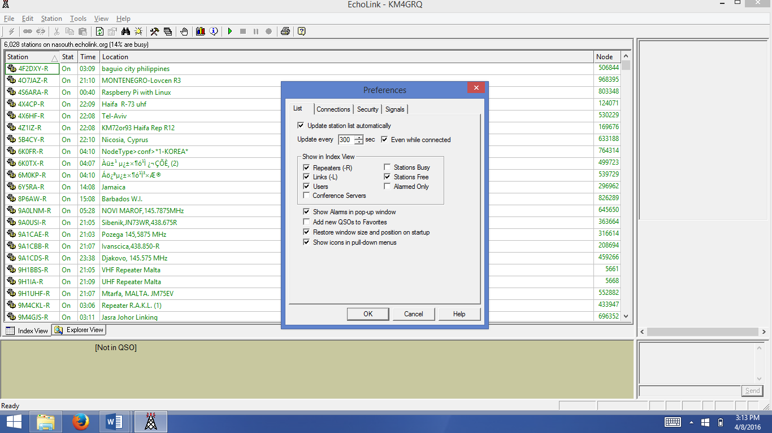

Check or uncheck the boxes of the types of connections you’d like to see.

1. To customize your connections a little more, select the “Connections” tab in Preferences. It will look something like this:

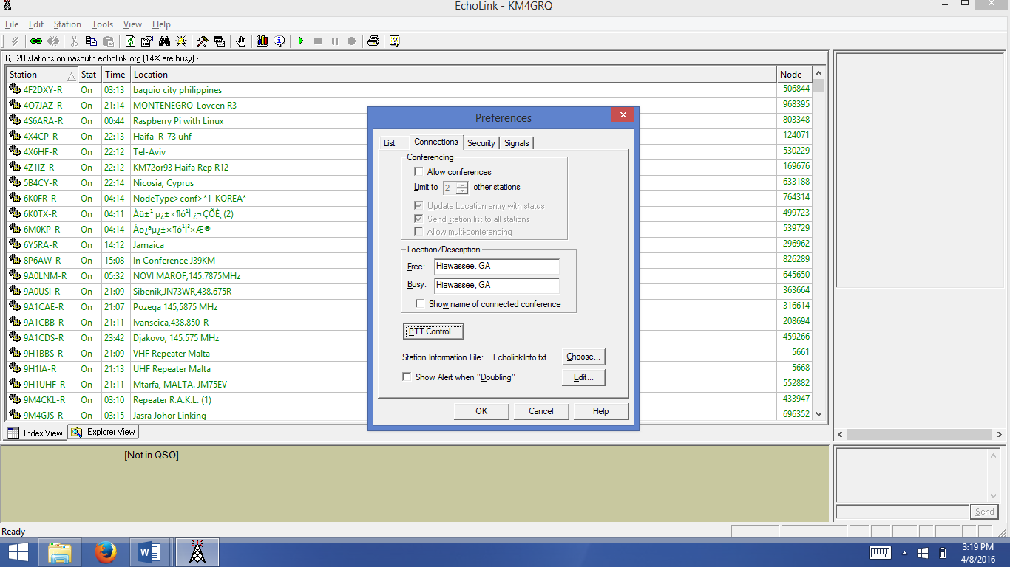

Most items are self-explanatory. Two items – “PTT Control” and “Station Information File” – will be covered here.

If you click on the “PTT Control” button, you’ll see the following:

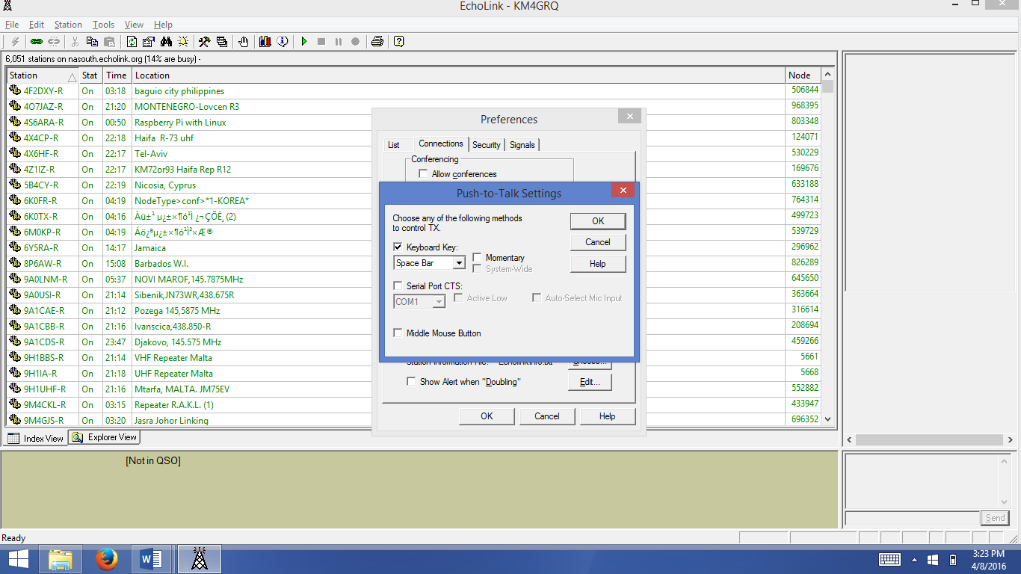

As you can see, you can use a keyboard key to control when you transmit. The default is the space bar. Clicking on the down-arrow of the dropdown list box shows your other options:

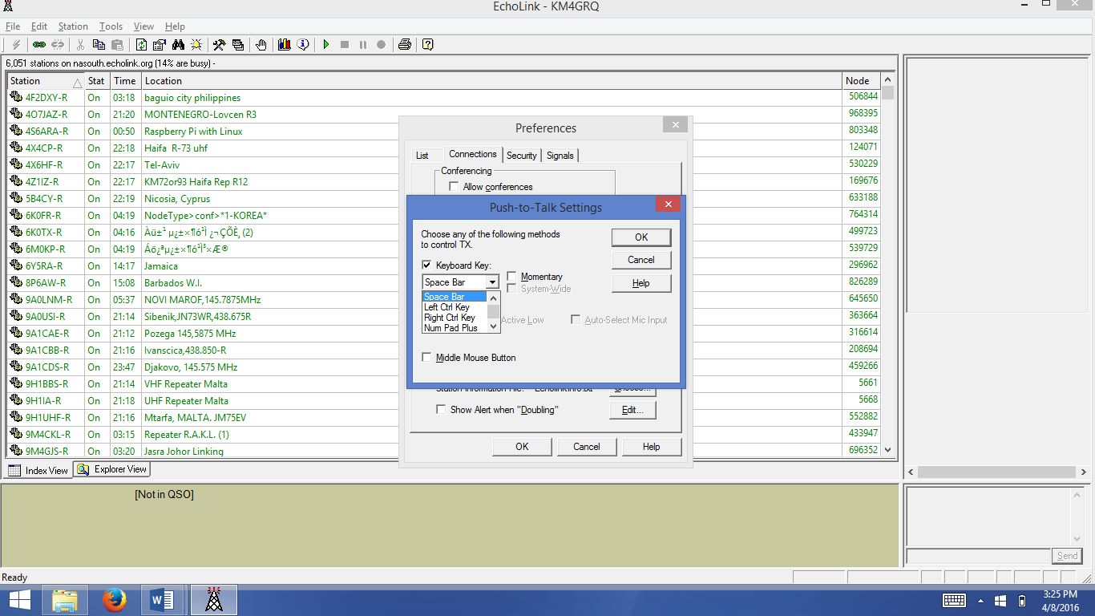

You can also use the Left or Right Ctrl Key, or the plus sign on the number pad (if your computer has one) to control transmitting. Keyboard keys are more convenient than clicking on the “lightning bolt” key located at the top-left of the echolink screen.

Also from the Connections tab in Preferences, you’ll notice “Station Information File” and a “Choose” button next to this text (in this example Echolinkinfo.txt appears):

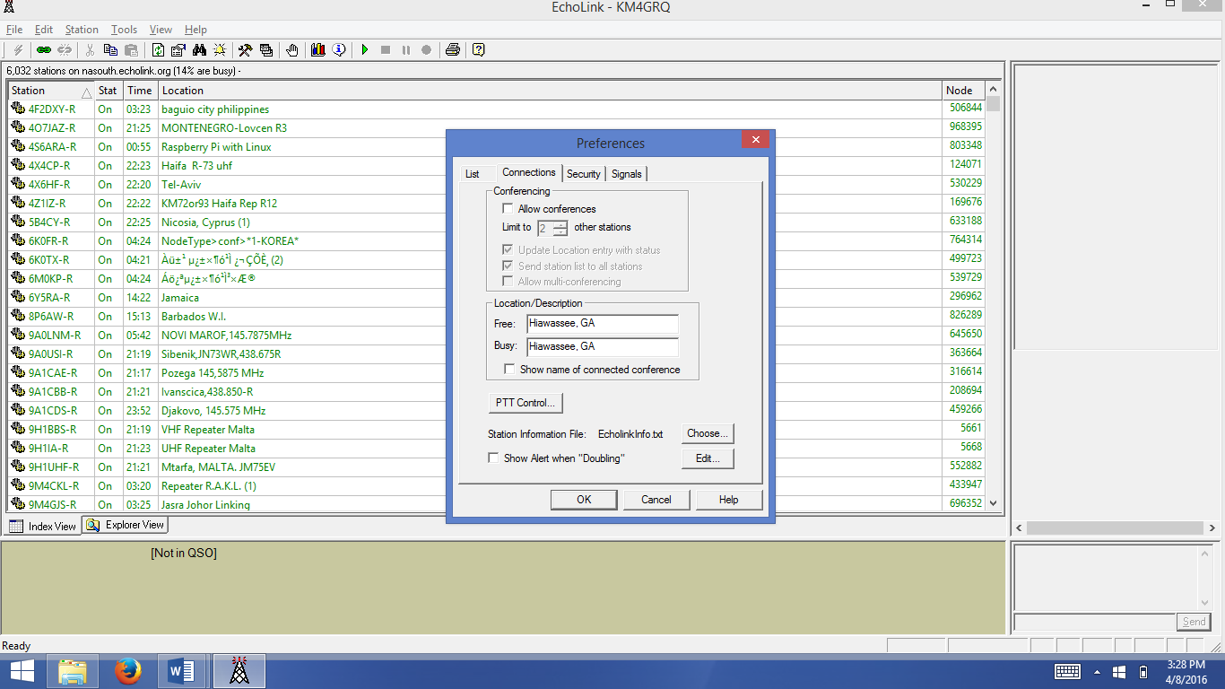

The Echolinkinfo.txt file is a filename of your choosing that you create on your computer that has additional information about you and your station. For repeaters, this may contain useful information about a local radio club, the frequency, offset, and tone of the repeater, or other pertinent information. You can create such a text file with word processing software and then save the file with the “.txt” extension. Once created, the “Choose” button will allow you to navigate to the location where your text file is stored. Once associated with EchoLink, you can then edit the file by clicking on the “Edit” button. The result will be the contents of your text file as the example shows, below:

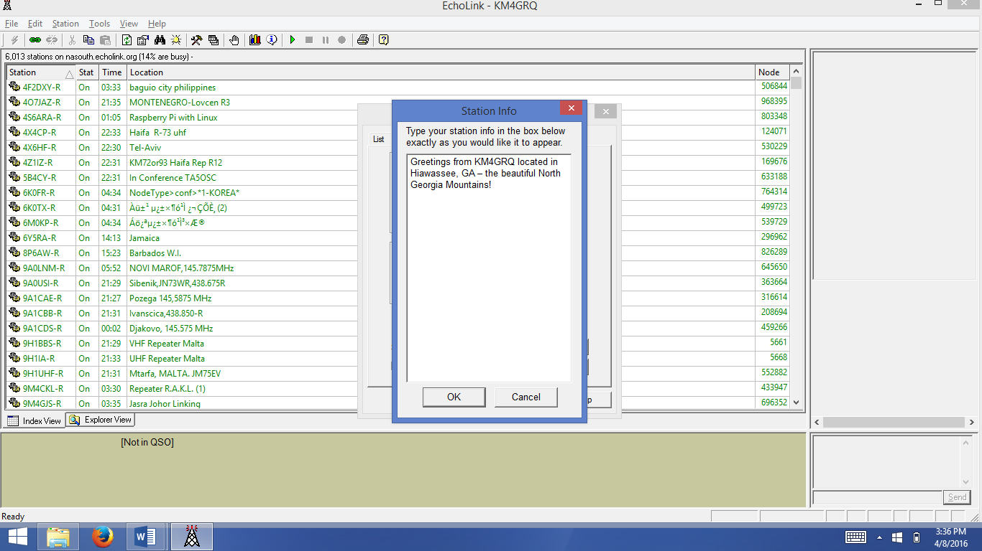

One final set-up step concerns your firewall settings.

1. You ***may*** also need to update your firewall to allow echolink to communicate through your firewall if you got an error during the EchoLink Firewall test. Go to the Control Panel and select Windows Firewall, then “Allow an app or feature through Windows Firewall”. A sample of this screen follows (if you didn’t get an error, then you don’t need to do this. “Private” means your network at home; “Public” means a network in a café, airport, restaurant, or other public place):

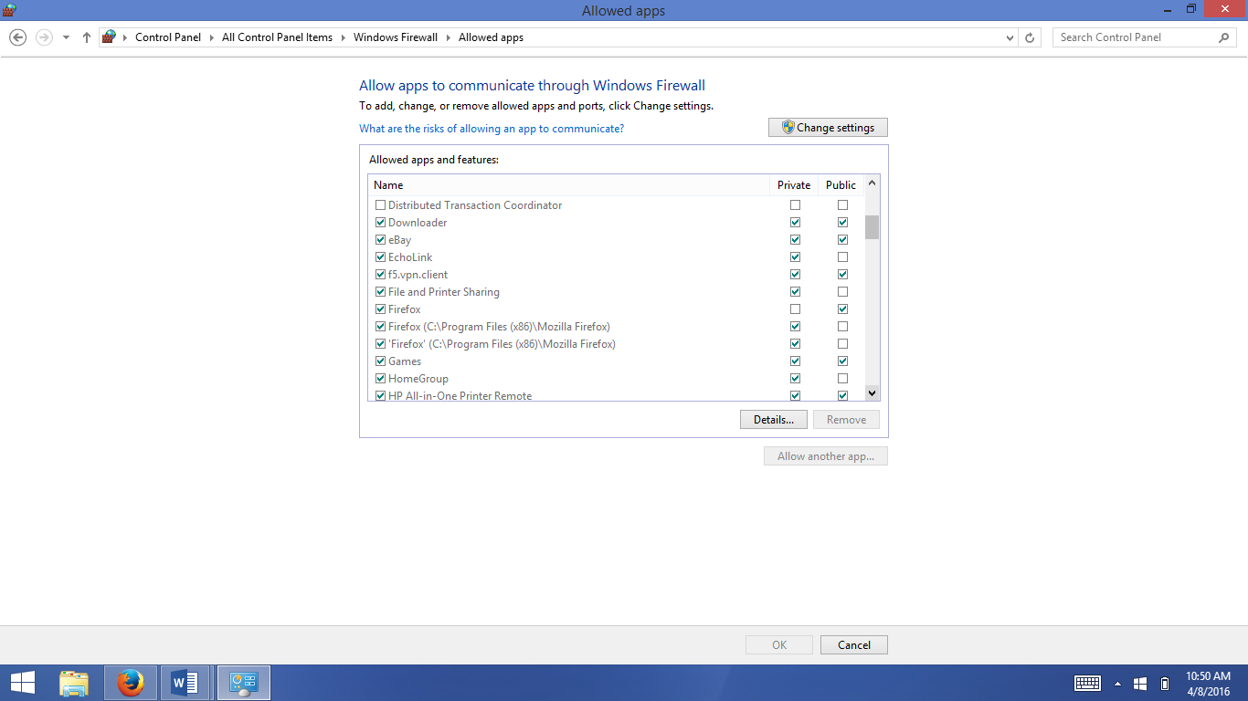

# Port Forwarding

## Introduction to Port Forwarding

Many applications – particularly gaming devices – need special access to various ports in the router provided by your Internet Service Provider. EchoLink passes information through ports 5198 and 5199 via User Datagram Protocol (UDP). A datagram is a self-contained packet of information that is passed between two communicating sources. If you are receiving “TIMED OUT” messages from EchoLink when trying to connect to another station, it is likely because the station you are trying to communicate with is attempting to send information back and forth through ports 5198 and 5199. If these ports are not identified to your router, it doesn’t understand what to do with that information, and so, the connection times out.

There are a couple of ways to port forward. One method entails obtaining what is called a “Static IP Address” for your computer and then changing your router to recognize ports 5198 and 5199 to pass them directly to the IP address of the computer running EchoLink. As you can imagine, there are several drawbacks to this method and the set-up is more involved.

The second method of port forwarding, is to define ports 5198 and 5199 as specific to a particular program – in our case, EchoLink. By defining a particular program to deal with these ports rather than a single IP address, the definition isn’t tied to one particular device. This method is what is demonstrated here.

**IT IS VERY IMPORTANT THAT YOU VISIT YOUR INTERNET SERVICE PROVIDER’S WEBSITE TO DETERMINE HOW TO UPDATE YOUR ROUTER. EACH ROUTER IS DIFFERENT, HOWEVER, THE BASIC PRINCIPLES APPLY. THE SCREEN SHOTS, BELOW, ARE AN EXAMPLE ONLY AND MAY NOT APPLY TO YOUR PARTICULAR SITUATION.**

## Port Forwarding Steps

1. Launch your browser and go to: <http://192.168.254.254>
2. You’ll be asked for a userid and password. Almost always, the userid will be admin, and the password will be admin. The left side of this particular screen looks like this:

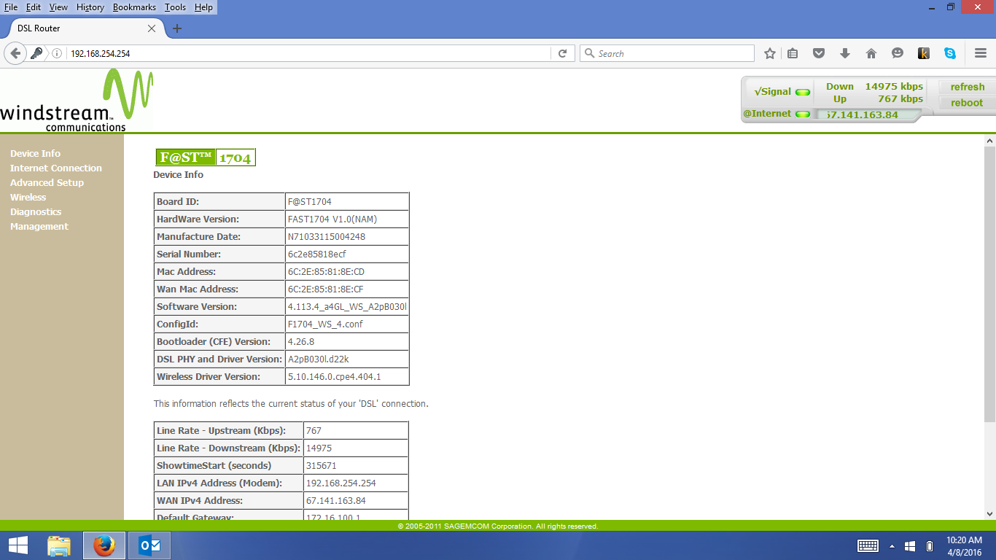

1. The full screen looks something like this:



1. You’ll need your router’s NAT (Network Address Translation) settings. In this case, it’s under “Advanced Setup”. The example shows that I’ve selected “Port Triggering” under the NAT header.

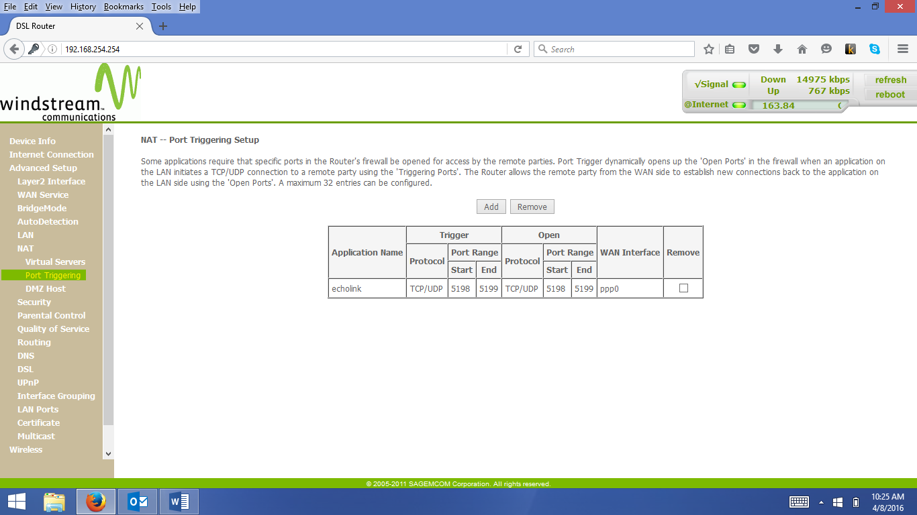



1. Click on the “Add” button to give the port range 5198-5199 the TCP/UDP port protocol. You’ll also need to explicitly state what program needs these ports for this protocol. In this case, “echolink” is the program name (enter it all lower-case, no quotes).

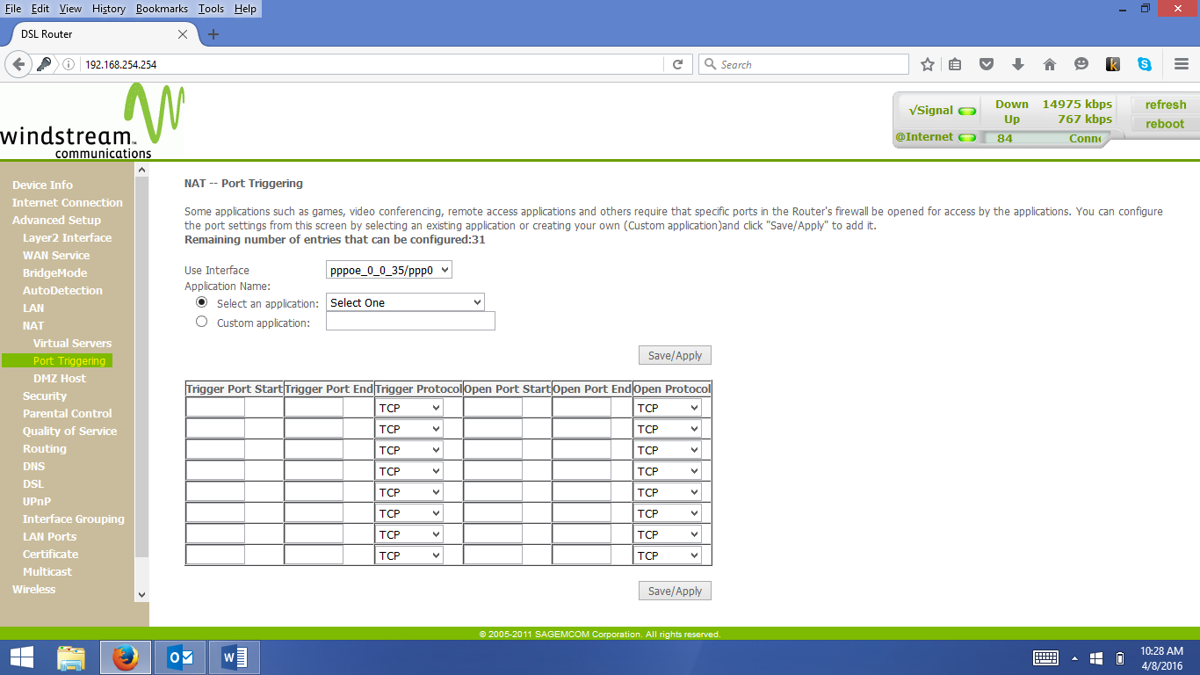

1. Click the “Custom Application” button and enter echolink for the program name. In the “Trigger Port Start” and “Open Port Start” boxes, enter 5198. In the “Trigger Port End” and “Open Port End” boxes, enter 5199. In the dropdown list boxes where “TCP” is shown, select “TCP/UDP” for both the “Trigger Protocol” and “Open Protocol. Finally, click “Save/Apply”. The resulting screen is given, below:

